A000-Afr-Gabon-Fang-Byeri-Reliquary figure-Female-Wood-Early 20th c

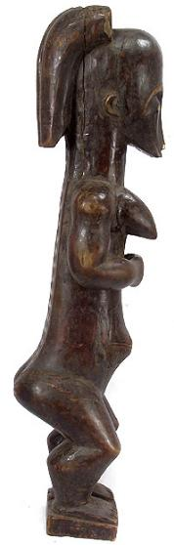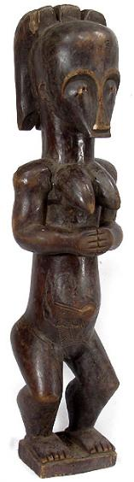 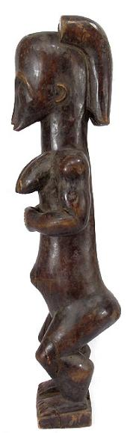 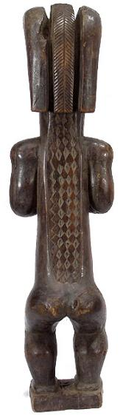

Figs 1-4. Afr-Gabon-Fang-Byeri-Reliquary figure-Female-Wood-Early 20th c

Case No.: 6

**Accession No.**

**Formal Label:**

**Display Description:**

This standing female reliquary figure is carved in a Fang sculptural style shown in a gesture of prayer, a motif seen in other examples of Fang sculpture. According to the typology developed by Louis Perrois, this figure has a concave face with a type 3 casis form of cranium with a vertical back, and a type 1 central crested helmet hair style (Perrois 1990:98). The moutn is wide and thin on a level with the chin and the nose is flat-based. The posture of the arms is type 5, in a gesture of offering, and thee legs are extended (Perrois 1990:99). The figure is covered by an oily application of palm oil and copal resin. The heart-shaped face, stylized facial features and body shape locates the figure among the Ntumu, a northern Fang sub-group. The keloid scarifications on the back and navel areas are unique. The posterior keloids suggest three strings of cowrie shells, a powerful female fertility symbol, and a stylized serpent, a powerful male sexual symbol. The keloids in the navel area suggest a familial symbol as a circle surrounds the navel with two diagonal lines extending laterally and parallel fringe lines extend downwards as though imitative of an apron. Therefore, it appears that this figure is a connected with female fertility rites.

Fang figures hold a prominent place in the history of African art. As reliquary guardians,  *byeri* reliquary figures held the bones of ancestors and they were venerated through annual ceremonies. Photographed as early as 1907 (Tessmann 1913/1972, vol. II) the cult of Byeri began to lose its prominence after 1910 due to French colonial government pressure. In the past, figures would often be embellished with native copper bands around arms or wrists and some would hold in front of them miniature ancestor figures or carved animal horns known as Nlakh or small cups used in Byeri rituals honoring ancestors.

It is the bieri, or ancestor sculpture, which has most obviously given rise to the making of remarkable wooden sculpture. The statuary of the Fang can be classified into three main groups: heads on long necks, half-figures and full figures, standing or seated.

Carved with great simplicity, at the same time they exhibit a high degree of sophistication in the coordination of bulbous forms. The neck is often a massive cylindrical form. The arms have various positions: hands clasped in front of the body (sometimes holding an object); held in front of the chest or attached to it; hands resting on the knees in the seated figures. The navel is often exaggerated into a cylindrical form. Legs are short, stunted. Usually there is a domed, wide forehead and the eyebrows often form arcs with the nose. The eyes are often made of metal roundlets.

The bieri would be consulted when the village was to change location, when a new crop was planted, during a palaver, or before going hunting, fishing, or to war. But once separated from the reliquary chest, the sculpted object would lose its sacred value and could be destroyed. The ritual consisted of prayers, libations, and sacrifices offered to the ancestor, whose scull would be rubbed with powder and paint each time. With its large head, long body, and short extremities, the Fang bieri had the proportion of a newborn, thus emphasizing the group’s continuity with its ancestor and with the three classes of the society: the “not-yet-born,” the living, and the dead.

The relics were essentially skull fragments, or sometimes complete skulls, jawbones, teeth and small bones. The bieri also served for therapeutic rituals and, above all, for the initiation of young males during the great so festival.

The Fang used masks in their secret societies. The ngil (gorilla) masks were worn by members of a male society of the same name during the initiation of new members and the persecution of wrong-doers. Masqueraders, clad in raffia costumes and attended by helpers, would materialize in the village after dark, illuminated by flickering torchlight.

Fang masks, such as those worn by itinerant troubadours and for hunting and punishing sorcerers, are painted white with facial features outlined in black. Typical are large, elongated masks covered with kaolin and featuring a face that was usually heart-shaped with a long, fine nose.

 Apparently it has been linked with the dead and ancestors, since white is their color.

The ngontang dance society also used white masks, sometimes in the form of a four-sided helmet-mask with bulging forehead and eyebrows in heart-shaped arcs. The ngontang mask symbolizes a ‘young white girl’. The so, or red antelope was connected with an initiation that lasted several months; these masks sport long horns.

Containers made of either bark or woven basketry were surmounted by sculpted figures known as eyema-o- byeri that guarded the remains of Fang ancestors (Fernandez 1975: 723-46). When not in actual use the sculpted figures were generally hidden from view. This figure most probably was placed on a family altar where it was venerated. Fang memorial sculpture has a long history of use and was in fact photographed as early as 1907 (Tessmann 1913/1972, vol. II) . However the cult of Byeri began to lose its prominence after 1910 due to colonial government pressure.

**LC Classification:**

**Date or Time Horizon:**

**Geographical Area:**

**Map:**

**GPS coordinates:**

**Cultural Affiliation:**

**Media:** Wood, stain and pigment.

**Dimensions: H** 23.5 in

**Weight:**

**Condition:** cracks in head. face, neck , shoulders and arms, torso and legs , some cracks  have received indigenous repairs, chips, dents and scratches.

**Provenance:**

**Discussion:**

During migrations which took place in the late eighteenth and early nineteenth centuries the Fang people moved to their present area becoming part of a complex overlay of population of approximately 200,000, who stretch from southern Cameroon into Gabon and Equatorial Guinea. Living in small forest communities the Fang focused upon tightly knit kinship and lineage systems and the veneration of ancestors through the use of figurative sculptures. Each lineage's ancestors were located in family shrines where memorials or reliquary boxes known as byeri, containing their bones were under the care of an elder known as the Esa.

The great rain forest region where the Fang settled is a plateau of middle altitude, cut by innumerable waters with falls and rapids rendering navigation for the most part impossible, and with a climate typically equatorial.

Fang are principally hunters but also agriculturists. Their social structure is based on a clan, a group of individuals with a common ancestor, and on the family. The ensemble of Fang peoples practice a cult devoted to ancestor lineages, the bieri, whose aim is to both protect themselves from the deceased and to recruit their aid in matters of daily life. This familial cult does not monopolize the Fang’s religious universe, for it coexists with other beliefs and rituals of a more collective character.

**References:**

Fernandez, J. 'La statuaire Fang-Gabon', African Arts, 8, No.1, 1974.

Fernandez, J. W. and R. L. 'Fang Reliquary Art: Its Quantities and Qualities.'Cahiers d'etudes africaines, 15, No. 5. 1975

Perrois, L. Statuaire fang, Paris. 1972

Perrois, L. Sculpture traditionelle du Gabon, Paris. 1977

Tessmann, G. Die Pangwe, Berlin and New York. 1913(1972)

Appendix:

SHAPE \* MERGEFORMAT 